**DIABETICS HOSPITALIZATION**

LAKSHMI SUNDARARAJAN

California State University Los Angeles

1. DATA SET URL

* <http://www.healthdata.gov/dataset/public-health-statistics-diabetes-hospitalizations-chicago-2000-2011>
* <http://www.healthdata.gov/dataset/hospital-inpatient-prevention-quality-indicators-pqi-adult-discharges-county-sparcs>
* <https://data.cityofchicago.org/api/views/j6cj-r444/rows.csv?accessType=DOWNLOAD>

1. DATA CLEANING

|  |  |  |
| --- | --- | --- |
| SCOPE / PROBLEM | DIRTY DATA | CLEANED DATA |
| 1. Missing values and   Removal  of unused  Field. | COL.PNG  sheet 2 null.PNG | Null values removed  sheet 2 not null.PNG |
| 1. Removal of repeating values | sheet 2 null.PNG | Null and repeating values removed  Removal of repeating value.PNG |
| 1. Wrong Refer-ence Removal | wrong reference 2.PNG  wrong ref ans.PNG | wrong.PNG |
| 1. Duplicated Records | Duplicate records removed  duplicate.PNG | The column cause of death removed  dup 2.PNG |
| 1. Embed-ded Values | No Embedded values  dupli.PNG | dupli.PNG |

1. DATA VISUALIZATION
2. Measure of Hospitalized patients with diabetics in different zip code

Application Learnt In Class: **Geographic Maps**

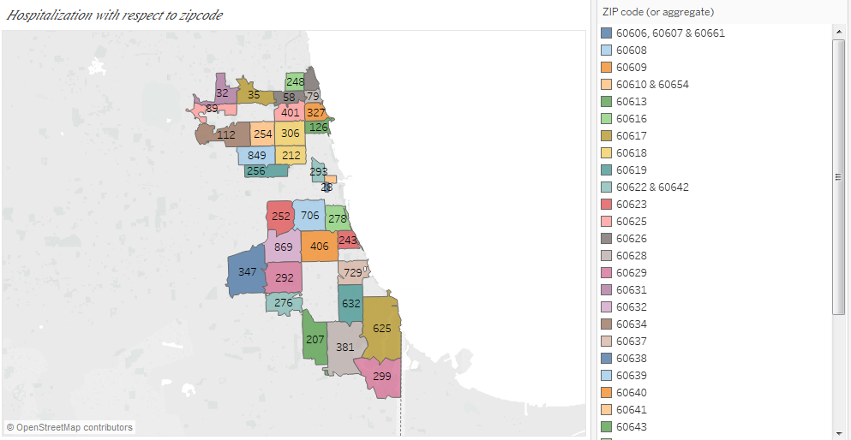

This Geographical chart displays the count of diabetics patients hospitalized in each zip code. The difference is showed by placing zip code in color and hospitalization count in Label. This Representation can be used as a reference to further analyze if it has been increased or decreased over the years.

1. Top 10 Diabetics hospitalization in different areas through the years

Application Learnt In Class: **Rank**

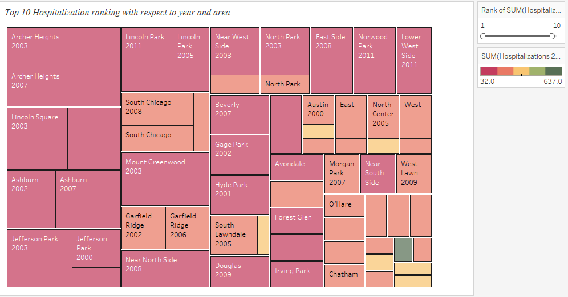

In the above Tree Map chart the ranks of top 10 hospitalizations of patients through the years 2000 to 2011 with its corresponding areas is represented. The rank function is used to show the increase or decrease in hospitalization in the areas through the years. For example Jefferson Park diabetic’s hospitalization increased from rank 4 in 2000 to rank 8 in 2003.It also shows the instability of hospitalization i.e. the sum of hospitalization measure fluctuates through the years.

1. Differences between observed and expected rates of PQI with respect to the type of

Diabetics?

Application Learnt In Class: **Calculated Field and Dual Axis Chart**

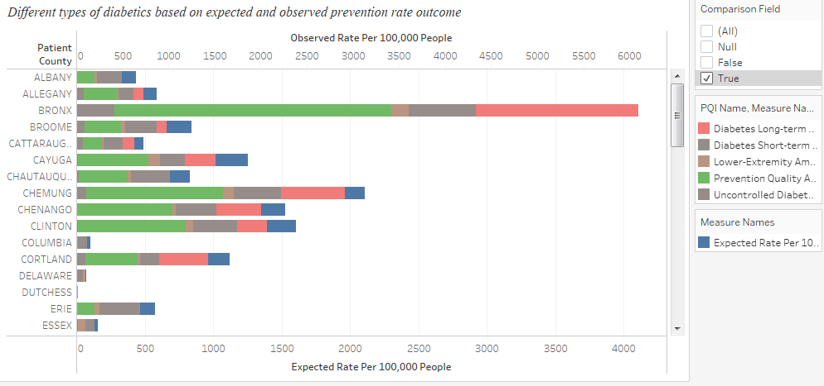

The above Bar chart shows the categories of diabetics based on prevention quality indicator. The indicator is expected patients with diabetics to the observed patients with diabetics represented in dual axis. It also shows the community area wise segregation of types of diabetics. A calculated field named Comparison Field is added in the above visualization in order to show if expected rate (Predicted rate) is lesser than the observed rate (Actual Rate).In this screenshot the value True indicates that the actual rate is higher indicating the prevention control for diabetics needs to be increased.

1. Analysis between average crude rates of deaths to the crude rates of hospitalization

Application Learnt In Class: **Reference Line**

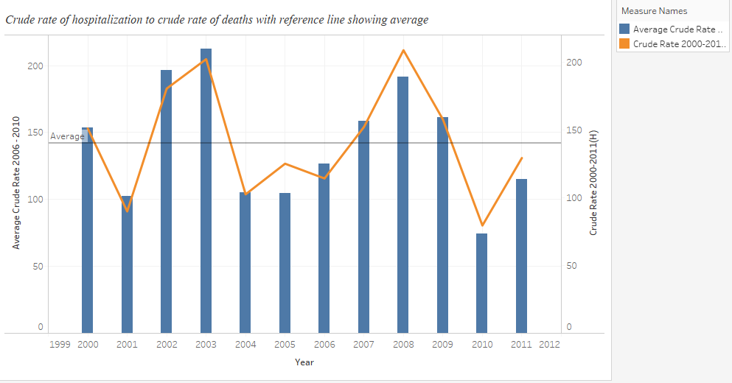

Crude rate is basically total number of events occurring in an entire population over a period of time. Here two such events are compared i.e. average crude rate of deaths to

crude rates of hospitalization. These two events are represented in the marks card under colors as Measure names. Over the years 2000 to 2011 this chart explains

the raise or drop of events in order to maintain an average between the two. This average

is represented using the reference line

1. Average annual deaths due to diabetics

Application Learnt In Class: **Groups**

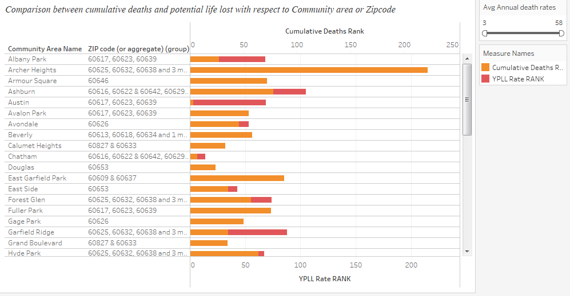

This Chart illustrates the average annual deaths with respect to two measures. One is Cumulative Deaths Rank(Rank based on Total no of deaths ) and YPLL Rate Rank (potential life lost over the years). By comparing these two measures one can predict the average annual death rates. These measures are represented for two dimensions those are community area and zip code. The zip codes are grouped with respect to area for which the group function is applied. This Analysis can be used to maintain or reduce the death rates without further raise.

1. Based on the Prevention Quality Indicator how diabetic’s is spread amongst regions.

Application Learnt In Class: **Scatter Plot**

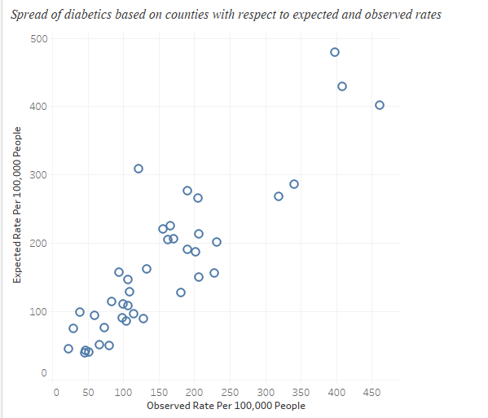

The above chart shows the spread of diabetics amongst different regions with the help of a scatter plot. The measures used are expected and observed rates of 100,000 patients with diabetics. It also represents region wise comparison of patients expected to have diabetics to the patients observed with diabetics.

1. Existing rate of hospitalization to the average annual deaths and its Forecast.

Application Learnt In Class: **Forecast**

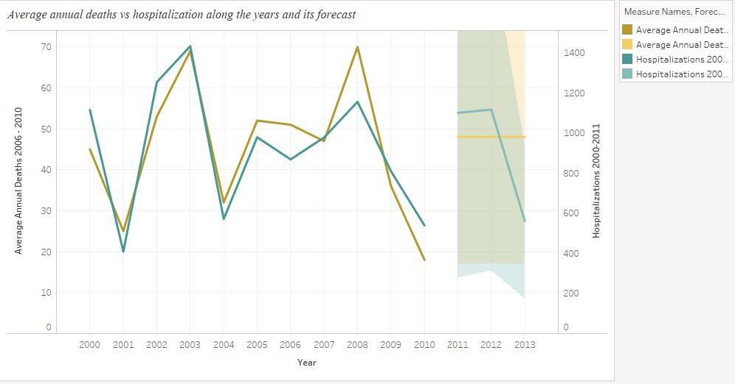

The above chart shows the rates of hospitalization to the average annual deaths through the years 2000 to 2011. Hospitalization measure refers to the number of people hospitalized with diabetics and average annual deaths is the measure of life lost due to diabetics. We can also get an insight on the drop or raise of hospitalization to deaths over years. For example in 2010 the rate of deaths is significantly less than hospitalization. The forecast is used to determine the rates for future and it is seen that the hospitalization rate reduces significantly but the death rates is maintained on an average scale.

1. DASHBOARD

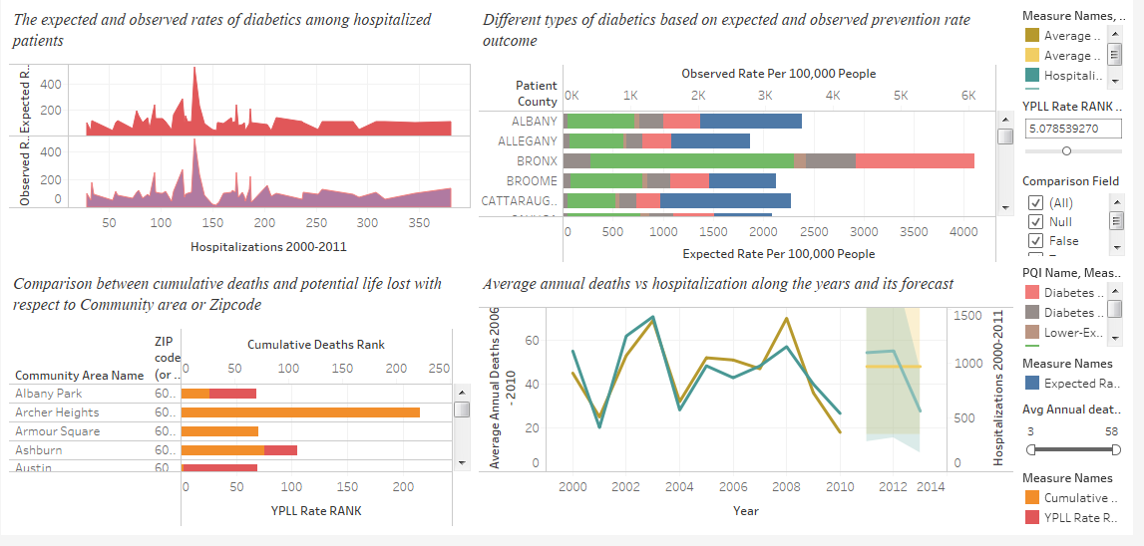

Dashboard displays the four elements of analysis such as

* Expected and Observed rates of diabetics among hospitalized patients
* Different types of diabetics based on expected and observed prevention rate outcomes
* Comparison between cumulative deaths and potential life lost with respect to community area and Zip code
* Average annual deaths vs hospitalization along the years and its forecast

1. STORY TELLING

Diabetes is a common secondary diagnosis disease in hospitalized patients. In the early years of

diabetes detection it was more prevalent on discharged patients which led to a lot of

readmissions. Patients with diabetes are hospitalized twice as often as others without this disease.

Furthermore, the need for inpatient diabetes care got increased in United States.

Due to this need, a great deal of attention has been given to improving the outpatient

management of patients with diabetes. Recommendations for managing patients with the acute

complications of diabetes are well established (a).Also due to undiagnosed diabetes the mortality

rates of hospitalized patients had been analyzed (b).However, few guidelines have been

formulated for inpatient management when diabetes is a secondary diagnosis.

So the inpatient hospitalization trends from the year 1994 to 2004 was analyzed to describe the

characteristic of delivery hospitalization in United States (c).All these factors taken into account

the importance of hospitalization analysis has become the need of the hour. Hence the analysis

done in this project gives the insight on five main research questions.

Starting with the analysis of areas which have the highest rates of hospitalization through the years we found an insight that there was no stability of hospitalization i.e. the sum of hospitalization measure fluctuates through the years. This led to the question of how widely has diabetics spread among the patient counties(communities with hospitalized patients).The measures used for this were expected and observed rates of 100,000 patients with diabetics. It was represented by scatter plot indicating the spread of diabetics through each region of patients expected to have diabetics to the patients observed with diabetics.

Next research question was based on what prevention measure is available for stopping this wide spread which was shown by differences between observed and expected rates of PQI (prevention quality indicator) with respect to the type of Diabetics. In this the analysis was done to determine the prevention control status and it was found that the actual rate of observed diabetics is higher indicating the prevention control for diabetics must to be increased.

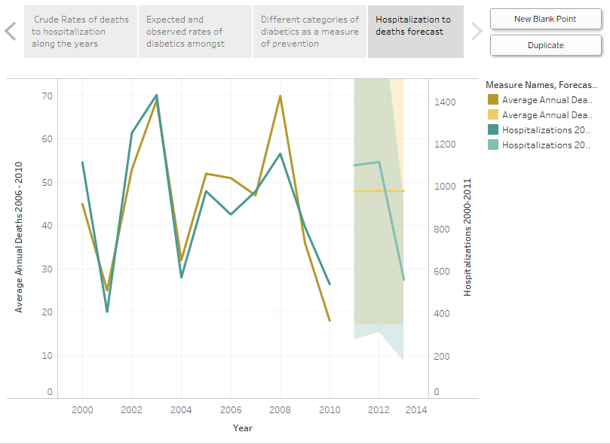

The next concern for research was the rates of hospitalization to the average annual deaths.

Hospitalization measure refers to the number of people hospitalized with diabetics and average annual deaths is the measure of life lost due to diabetics. We can get an insight on the drop or raise of hospitalization to deaths over years. For example in 2010 the rate of deaths is significantly less than hospitalization. The forecast is used to determine the rates for future and it is seen that the hospitalization rate reduces significantly but the death rates is maintained on an average scale. So in this scenario the comparison of cumulative deaths rank and potential life lost becomes mandatory to determine the average annual death rates. This was done by comparing the measures of cumulative deaths and potential life lost with respect to area or Zip code. Hence this Analysis can be used to maintain or reduce the death rates without further raise.

REFERENCES

1. Lombardo, Flavia, Marina Maggini, Gabriella Gruden, and Graziella Bruno. "Temporal

Trend in Hospitalizations for Acute Diabetic Complications: A Nationwide Study, Italy,

2001-2010: E63675." *PLoS One*, 8.5 (2013)

<http://xerxes.calstate.edu/losangeles/articles/record?id=FETCH-LOGICAL-p866-7ab51a90afe1db651cd0db3a36a0400afa75715eb6c39c069a8c65a51e46c4bd3>

1. Division of Endocrinology and Metabolism, University of Tennessee Health Science

Center (G.E.U., A.E.K.), Memphis, Tennessee 38163; Department of Medicine, Atlanta

Medical Center (S.D.I., N.B., X.Y.), Atlanta, Georgia; and Department of Medicine,

Emory University School of Medicine (L.M.T.), Atlanta, Georgia.

<http://press.endocrine.org/doi/abs/10.1210/jcem.87.3.8341>

1. Albrecht, Sandra S, Elena V Kuklina, Pooja Bansil, Denise J Jamieson, Maura K

Whiteman, Athena P Kourtis, Samuel F Posner, and William M Callaghan. "Diabetes

Trends Among Delivery Hospitalizations in the U.S., 1994-2004." *Diabetes Care*, 33.4

(2010): 768-773.

<http://xerxes.calstate.edu/losangeles/articles/record?id=FETCH-LOGICAL-c3828-185e8d04169b069fd5a29e6999bf4bbedb3509a6baaf3842a6f5430f4703d3c23>